# IEMS5723 Assignment 3

## The Problem

With the use of Python Libraries NetworkX and PyDot, compute the betweenness centrality and find out the edge with highest betweenness centrality (any edge for the same highest betweenness centrality) and produce the network graph.

## The Input

The input file “input.csv” has less than 51 lines in comma separated format storing the adjacency matrix of a undirected graph. First row and first column are the node labels. Value ‘1’ (without quote) indicates the two nodes are connected.

## The Output

Two output files [Student ID].txt and [Student ID].png should be produced.

[Student ID].txt contains the list of betweenness centrality of all edges.

[Student ID].png is the network graph. The edge width should be five times of its betweenness centrality and the edge label should also indicate that value. All edge labels should be in blue color except the edge with highest betweeness centrality with edge label in red.

## Submission

A runnable Python program file should be submitted.

## Sample Input

,1,2,3,A,B

1,,,,1,

2,,,,1,

3,,,,,1

A,1,1,,,1

B,,,1,1,

## Sample Output

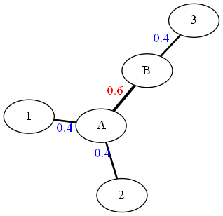The edge ('A', '2')'s betweenness is 0.4

The edge ('B', '3')'s betweenness is 0.4

The edge ('A', '1')'s betweenness is 0.4

The edge ('A', 'B')'s betweenness is 0.6